Programs day 4

1.WRITE A PYTHON PROGRAM TO CHECK IT IS A SUBSTRING OR NOT?

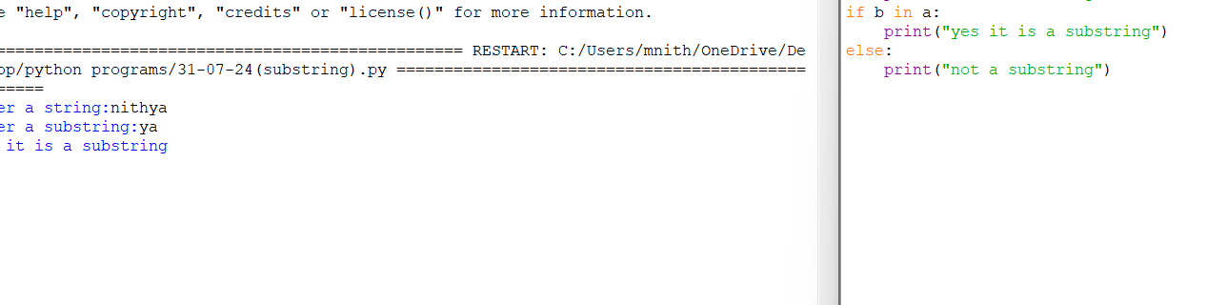

2.WRITE A PYTHON PROGRAM TO CONVERT UPPERCASE AND LOWERCASE OF A STRING?

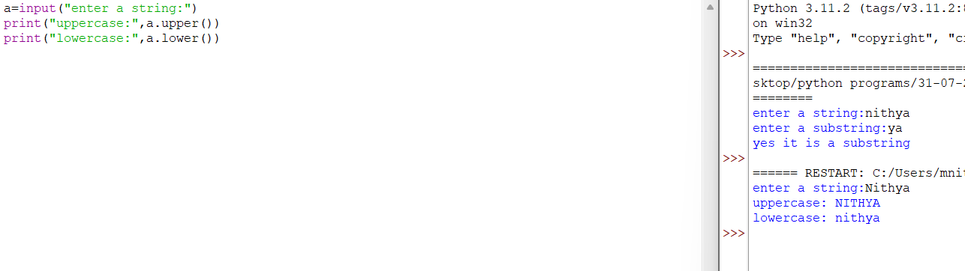

3.WRITE A PYTHON PROGRAM TO CHECK IT A PALINDROME OR NOT?

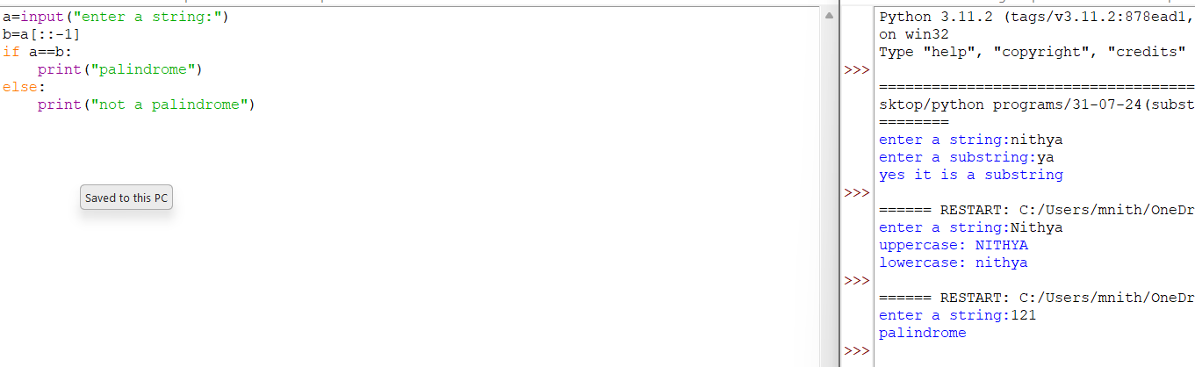

4.WRITE A PYTHON PROGRAM TO FIND NUMBER OF WORDS IN A STRING?

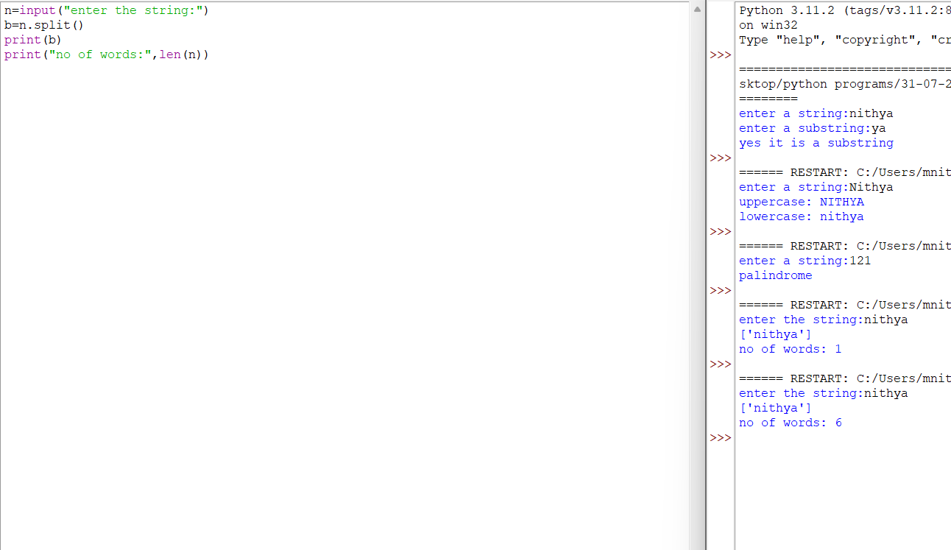

5.WRITE A PYTHON PROGRAM TO CHECK PERFECT NUMBER OR NOT?

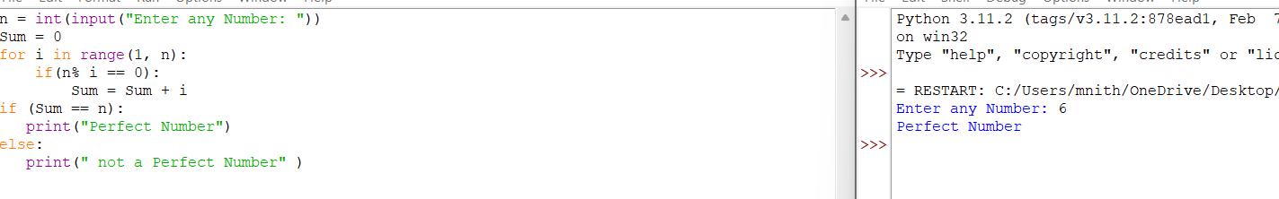

6.WRITE A PYTHON PROGRAM TO CHECK ARMSTRONG NUMBER OR NOT?

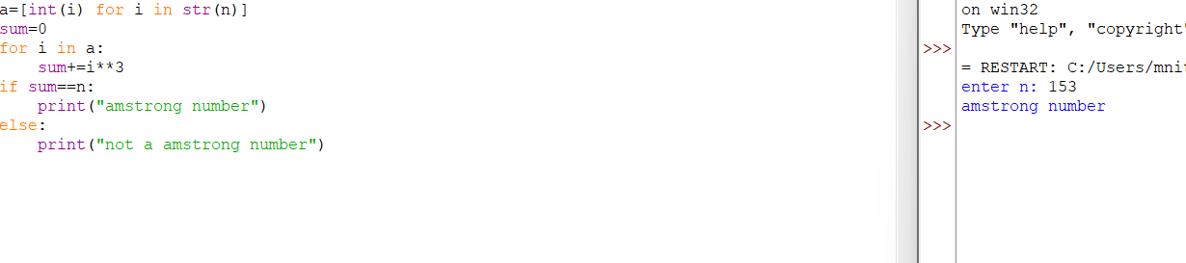

7.WRITE A PYTHON PROGRAM TO CHECK TECH NUMBER OR NOT?

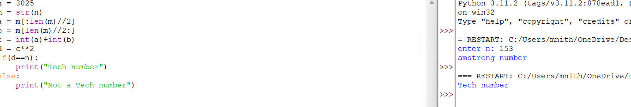

8.WRITE A PYTHON PROGRAM TO CHECK PRIME NUMBER OR NOT?

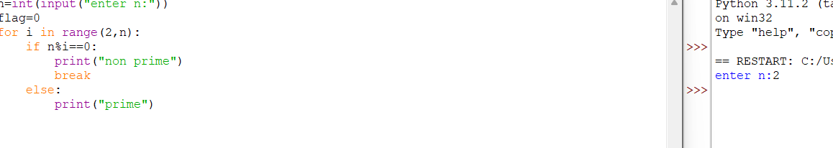

9. WRITE A PYTHON PROGRAM TO CHECK COMPOSITE NUMBER OR NOT?

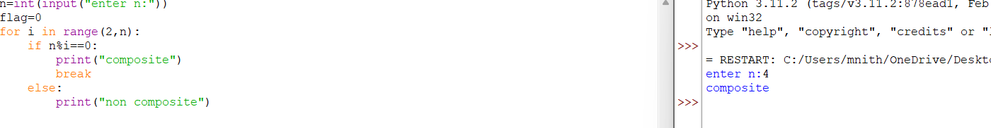

10.WRITE A PYTHON PROGRAM TO CHECK HARSHAD NUMBER OR NOT?

